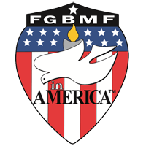
JERRY ZELINSKY
FGBMF of America
WA State Godmobile Director
23915 127th Pl. SE, Kent, WA 98031
Website: Godmobile.org

2026 GODMOBILE BANQUET

The FGBMFA Godmobile would like to invite you to the Godmobile Banquet Fundraiser on Saturday, March 21, 2026 from 2:00pm to 5:00pm at Sin Pancho Mexican Restaurant, 4202 Auburn Way North, Ste. 1, Auburn, WA 98002. There will be a delicious enchilada bar with chips, beverages and desserts for $20 per person charge, please text RSVP to Stan Abbott at 206-261-9000. Join us for worship, fellowship, testimonies and door prizes. This fundraiser will provide 2026 fair entry fees, volunteer tickets, bibles, tracts, bracelets and candy for these evangelistic ministry outreaches.

In 2025 we had an incredible year of salvations and conversations, and gave away numerous tracts and bibles in several languages! We finished the Washington State Fair in Puyallup with a record amount of salvations, 1,991!! We reached a total of 5,800 salvations for all the fairs, even with two fair cancellations!! We are looking forward to another awesome year at the many fairs here in the Pacific Northwest. Please go to Godmobile.org for more information.

Thank you for your continued support in volunteer help, giving and prayer, they are so appreciated. We hope to see you at the Godmobile Banquet Fundraiser!

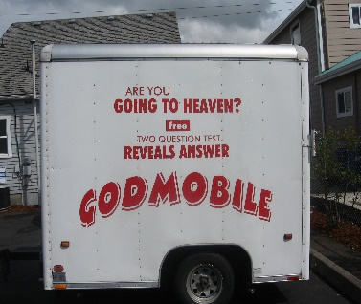
JERRY ZELINSKY,
WA State Godmobile Director

Phone: 425-246-2139 or
Email: Godmobile737@gmail.com

